**Name: Sunil Kunwar Roll No.: 114 IIB Date: 2080-06-02**

**M. Sc. 2nd Semester General Lab - 02**

**STUDY THE ABSORPTION OF α−PARTICLE IN THE AIR USING *AM-241* SOURCE AND END-WINDOW COUNTER.**

**APPARATUS REQUIRED:**

1. GM tube and Counter
2. Alpha Source
3. Scale

**THEORY**

Heavy particles, such as protons, are larger than electron masses in nuclear physics. The interaction of radiation with matter is characterized by the average decrease of particle kinetic energy per unit path length, denoted as the stopping power of the medium. The energy loss of heavy charged particles and electrons is ionization or excitation of matter atoms, which are excited or ionized due to the Coulomb force between the incident particles and matter electrons.

Activity of radioactive substance $A(t)$ at any time $t$ proportional to number of radioactive particles

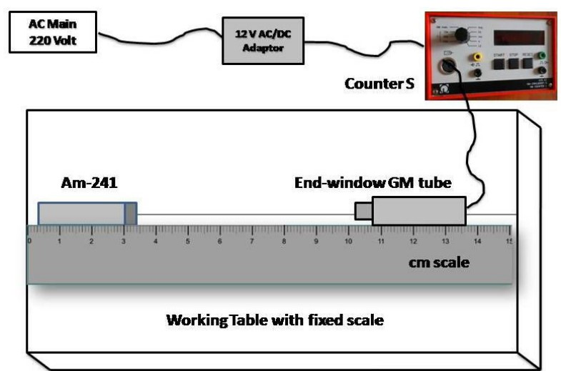

*Figure 1: The Experimental setup for alpha particle absorption.*

|  |  |
| --- | --- |
| $$A\left(t\right)=λ.N\left(t\right)$$ |  |

The number of radioisotopes present at time t, decays exponentially with time, i.e.,

|  |  |
| --- | --- |
| $$N\left(t\right)=N_{0}.e^{-λt}$$ |  |

In terms of mass absorption coefficient, we express λt = μmx. One can calculate mass absorption coefficient using above expression. These ionizing radiation shows wave properties and hence satisfies inverse square law, i.e., N(t) is inversely proportional to the square of the distance between the GM tube and the source.

The quantum mechanical calculation of the stopping power due to ionization energy losses is given by

|  |  |
| --- | --- |
| $$s=\frac{1}{4πE_{0}}\frac{z^{2}e^{4}n}{m_{e}ν^{2}}\left\{\ln{\frac{{2m}_{e}ν^{2}}{\overline{I}(1-β^{2})}}-β^{2}\right\}$$ |  |

The formula for particle velocity, charge, concentration, mass, electric constant, and excitation energy of atomic electrons is given by v = z/c, where v exceeds 107 m/s, corresponding to alpha particle energy of 2 MeV. It also considers the ratio of particle velocity and light velocity.

**BEST FIT CALCULATION:**

Let $y= \ln{N}$ and $x$ is the thickness of air, then

|  |  |
| --- | --- |
| $$y=mx+c$$ |  |

Represents the best fitted line, where m is the slope and c the intercept.

Taking sum, then above equation takes the form:

|  |  |
| --- | --- |
| $\sum{y=m\sum{x+nc}}$ |  |

Multiplying (5) by $\sum{x}$ we get,

|  |  |
| --- | --- |
| $\sum{xy=m\sum{x^{2}+c\sum{x}}}$ |  |

Multiplying (6) by $\sum{x}$ and (6) by $n$ and solving these expressions for the slope ($m$), we get,

|  |  |
| --- | --- |
| $$m=\frac{n\sum{xy-\sum{x\sum{y}}}}{n\sum{x^{2}-{\left(\sum{x}\right)}^{2}}}$$ |  |

And intercept $(c)$ is given by,

|  |  |
| --- | --- |
| $$c=\frac{\sum{y-m\sum{x}}}{n}$$ |  |

**OBSERVATIONS**

**The operating voltage of GM counter is 450v**

**Table 1:** Background Count

|  |  |  |
| --- | --- | --- |
| **SN** | **Counts per 10 sec** | **Average** |
|  | 39 | 21.4 |
|  | 18 |
|  | 13 |
|  | 22 |
|  | 15 |

So, average count per sec = $\frac{31.8}{10}=2.14$

We take observations of counts for different thickness of the air for 10 seconds only. So average background counts per second=2.14.

**Table 2:** With Source, Measurement of $α$-particle absorption

|  |  |  |  |  |  |  |  |  |  |
| --- | --- | --- | --- | --- | --- | --- | --- | --- | --- |
| **SN** | **Thickness (x cm)** | **Counts per 60 seconds** | | | | | **Average count** | **Average count per second** | **Background subtracted (N)** |
|  | 0.5 | 1211 | 1227 | 1179 | 1275 | 1227 | 1223.8 | 122.38 | 120.24 |
|  | 1 | 576 | 532 | 538 | 530 | 528 | 540.8 | 54.08 | 51.94 |
|  | 1.5 | 204 | 193 | 200 | 246 | 225 | 213.6 | 21.36 | 19.22 |
|  | 2 | 157 | 136 | 149 | 122 | 121 | 137 | 13.7 | 11.56 |
|  | 2.5 | 111 | 104 | 100 | 100 | 110 | 105 | 10.5 | 8.36 |
|  | 3 | 88 | 87 | 71 | 87 | 87 | 84 | 8.4 | 6.26 |
|  | 3.5 | 77 | 73 | 66 | 77 | 83 | 75.2 | 7.52 | 5.38 |
|  | 4 | 62 | 65 | 54 | 57 | 64 | 60.4 | 6.04 | 3.9 |
|  | 4.5 | 47 | 41 | 56 | 40 | 47 | 46.2 | 4.62 | 2.48 |
|  | 5 | 47 | 38 | 49 | 38 | 46 | 43.6 | 4.36 | 2.22 |
|  | 5.5 | 47 | 33 | 42 | 40 | 46 | 41.6 | 4.16 | 2.02 |
|  | 6 | 30 | 30 | 35 | 30 | 33 | 31.6 | 3.16 | 1.02 |

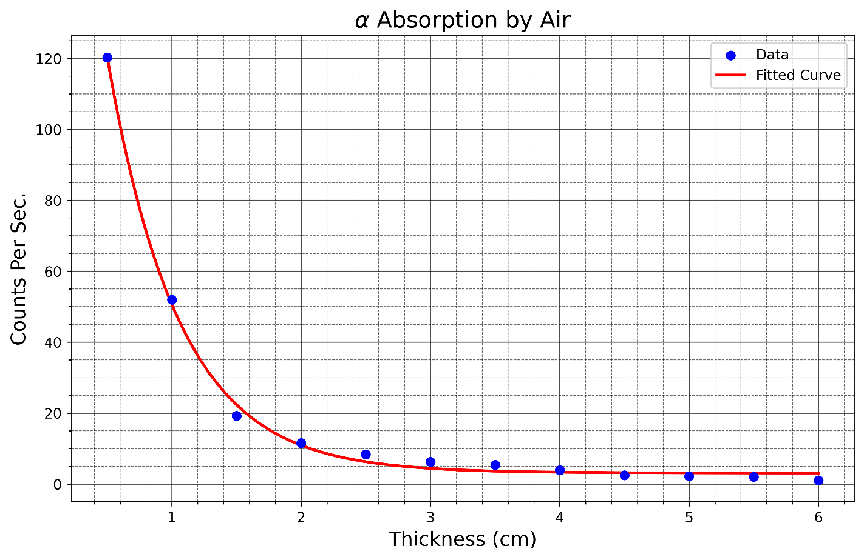

*Figure 2: The Experimental setup for alpha particle absorption of Am-241.*

**Table 3:** Best fit calculation.

|  |  |  |  |  |  |
| --- | --- | --- | --- | --- | --- |
| **SN** | $$x$$ | $$N$$ | $$y=\ln{N}$$ | $$x^{2}$$ | $$xy$$ |
|  | 0.5 | 120.24 | 4.79 | 0.25 | 2.39 |
|  | 1 | 51.94 | 3.95 | 1.00 | 3.95 |
|  | 1.5 | 19.22 | 2.96 | 2.25 | 4.43 |
|  | 2 | 11.56 | 2.45 | 4.00 | 4.90 |
|  | 2.5 | 8.36 | 2.12 | 6.25 | 5.31 |
|  | 3 | 6.26 | 1.83 | 9.00 | 5.50 |
|  | 3.5 | 5.38 | 1.68 | 12.25 | 5.89 |
|  | 4 | 3.90 | 1.36 | 16.00 | 5.44 |
|  | 4.5 | 2.48 | 0.91 | 20.25 | 4.09 |
|  | 5 | 2.22 | 0.80 | 25.00 | 3.99 |
|  | 5.5 | 2.02 | 0.70 | 30.25 | 3.87 |
|  | 6 | 1.02 | 0.02 | 36.00 | 0.12 |
|  | $\sum{x=}$**39** |  | $\sum{y}=$**23.57** | $\sum{x^{2}=}$**162.5** | $\sum{xy=}$**49.88** |

**Best fit calculation:**

Here, number of observations (n) =12,

$$m=\frac{n\sum{xy-\sum{x\sum{y}}}}{n\sum{x^{2}-{\left(\sum{x}\right)}^{2}}}=\frac{12×49.88-39×23.57}{12×162.5-{(39)}^{2}}=-0.7478 {cm}^{-1}$$

$$c=\frac{\sum{y-m\sum{x}}}{n}=\frac{23.57-(-0.7478)×39}{12}=4.3947$$

Therefore, the mass absorption coefficient for Am-241 in air is

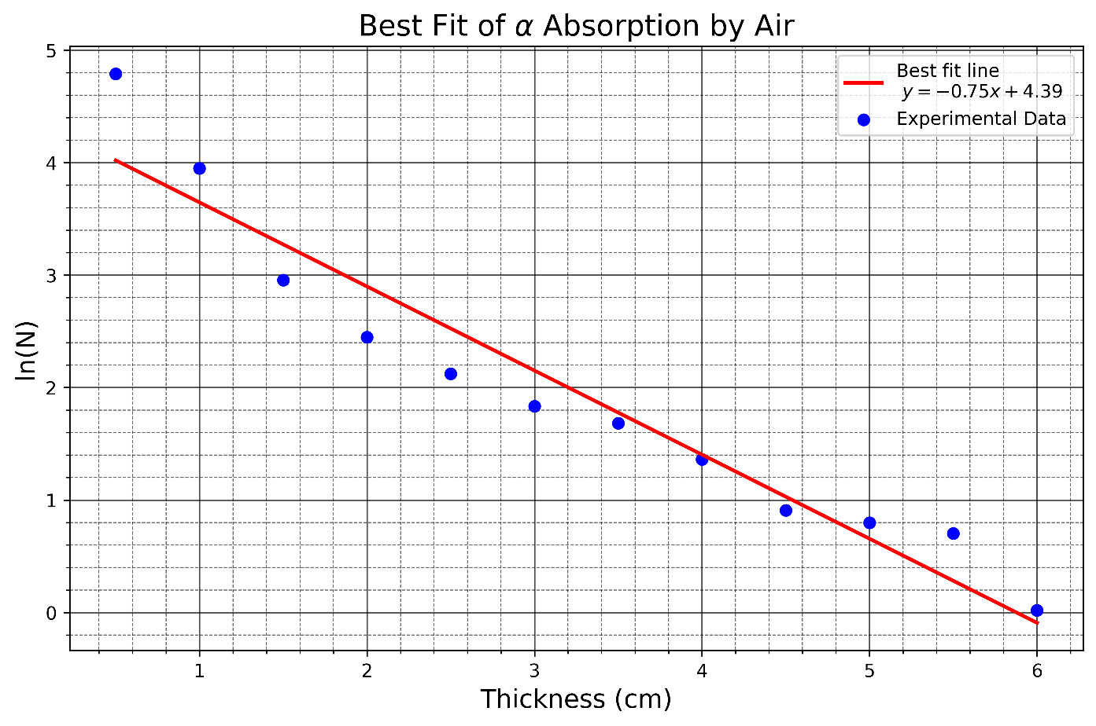

*Figure 3: The best fit graph of thickness and log of N.*

**Calculation of stopping power due to ionization energy for am-241 source:**

Calculations of stopping power due to ionization for Am-241

K.E. of $α$ particle (EK) =5.64 Mev

= 5.64x1.6.10-19x106 J

=9.024 x10-13J

EK =-

-1

or, $\frac{9.024x{10}^{-3}}{6.64x{10}^{-27}x{(3x{10}^{8})}^{2}}=\frac{1}{\sqrt{1-{v^{2}}/{c^{2}}}}-1$

or, $0.0015+1=\frac{1}{\sqrt{1-{v^{2}}/{c^{2}}}}$

or, $1.003= \frac{1}{(1-{v^{2}}/{c^{2}})}$

$∴v=1.64x{10}^{7}$ m/s

Density of Am-241

$ρ_mn=1200 kg/m^{3}$

Valence electrons of Am-241= 4

$n=\frac{N_{A}xρ_{Am}x4}{atomic_mass}=\frac{6.022x{10}^{23}x1200}{241}=1.199x{10}^{25}m^{-3}$

$\overline{i}=13.5Zev=13.5x95x1.6x{10}^{-19}=2.052x{10}^{-16}J$

$β=\frac{ϑ}{c}=\frac{1.64x{10}^{7}}{3x{10}^{8}}=0.0547$

S= $\frac{1}{4π{ϵ_{0}}^{2}} \frac{z^{2}e^{4}n}{m_{e}v^{2}\left\{ln \frac{2m_{e}v^{2}}{\overline{I}\left(1-β^{2}\right)}-β^{2}\right\}}$

$=\frac{95x{\left(1.6x{10}^{-19}\right)}^{2}x{1.199x10}^{25}}{4π{\left(8.85x{10}^{-12}\right)}^{2}9.1x{10}^{-31}x{\left(1.164x{10}^{7}\right)}^{2}ln\frac{2x9.1x{10}^{-31}x{\left(1.64x{10}^{7}\right)}^{2}}{2.052x{10}^{-16}\left(1-{0.0547}^{2}\right)}-0.0547^{2}}$

$=1.33x{10}^{-13}evm^{2}{kg}^{-1}$

**Error Analysis:**

**Table 4:** Calculation of error in m.

|  |  |  |  |  |  |
| --- | --- | --- | --- | --- | --- |
| **SN** | $$x$$ | $$y$$ | $$\hat{y}=mx+c$$ | $${\left(x-\overline{x}\right)}^{2}$$ | $$d_{i}^{2}={(y-\hat{y})}^{2}$$ |
|  | 0.5 | 4.79 | 4.02 | 7.56 | 0.59 |
|  | 1 | 3.95 | 3.65 | 5.06 | 0.09 |
|  | 1.5 | 2.96 | 3.27 | 3.06 | 0.10 |
|  | 2 | 2.45 | 2.90 | 1.56 | 0.20 |
|  | 2.5 | 2.12 | 2.53 | 0.56 | 0.16 |
|  | 3 | 1.83 | 2.15 | 0.06 | 0.10 |
|  | 3.5 | 1.68 | 1.78 | 0.06 | 0.01 |
|  | 4 | 1.36 | 1.40 | 0.56 | 0.00 |
|  | 4.5 | 0.91 | 1.03 | 1.56 | 0.01 |
|  | 5 | 0.80 | 0.66 | 3.06 | 0.02 |
|  | 5.5 | 0.70 | 0.28 | 5.06 | 0.18 |
|  | 6 | 0.02 | -0.09 | 7.56 | 0.01 |
|  | $∑x$**= 39.0** |  |  | **D=∑ ${\left(x-\overline{x}\right)}^{2}$ =35.75** | **∑ $d_{i}^{2}=1.48$** |

Mean $\overline{x}=$ 3.25

The error in slope is, $∆m=\sqrt{\left(\frac{∑{di}^{2}}{n-2}\right)×\frac{1}{d}}=\sqrt{\frac{1.48}{12-2}×\frac{1}{35.75}}=±0.064 {cm}^{-1}$

Hence the error in mass absorption coefficient for alpha particle = $±0.064 {cm}^{-1}$

So, the absorption coefficient = $0.7478 ±0.064 {cm}^{-1}$.

**RESULT:**

Hence, the absorption of alpha particle from Am-241 source was studied. The mass absorption coefficient for $α-$ particle is $0.07478 ±0.064 {cm}^{-1}$ and stopping power due to ionization energy is $1.33x{10}^{-13}eVm^{2}{kg}^{-1}$**.**

**DISCUSSION:**

Am-241 is the alpha source in our experimental configuration. In this experiment, we placed the source at different distances from the counter tube to obtain the count rate reading. The α-source and GM tube were placed between 0.5 and 6 cm apart. The average background counts every 10 seconds, which is 21.4, is determined first. We plot the graph to determine the count rate's nature, which is exponential, after making a variety of observations. We use the best fit method to calculate the air's slope (mass absorption coefficient).

It is determined that the mass absorption coefficient (-slope) is $0.07478 ±0.064 {cm}^{-1}$  
In summary, the logarithm of the count rate per second vs the distance from the GM tube displays a linear relationship.

……………………

(Signature)